The First Christian Missionaries
Activity: Look up the Bible verses and answer the questions in the table.
Lydia  Look up Acts 16:14-15 on BibleGateway | Where was she from?  What was she a dealer of?  Who did she worship?  Who did the Lord open her heart to?  How did she respond to Saint Paul’s message?
Tabitha  Look up Acts 9:36-42 on BibleGateway | What is her name in Greek?  What was she always doing?  What happened when she died?  What did Saint Peter do to her?  How did the people respond?
Priscilla and Aquila  Look up Acts 18:1-3 AND Acts 18:24-26 on BibleGateway | Who was Aquila?  What was Priscilla?  Why did Saint Paul stay with them?  Who was Apollos?  How did Priscilla and Aquila respond to Apollos?

Activity: Use your own knowledge to answer the questions below.
- What is a missionary?
- Why was Lydia a missionary?
- Why was Tabitha a missionary?
- Why were Priscilla and Aquila missionaries?

Research Task: Go to http://www.whatchristianswanttoknow.com/10-famous-christian-missionaries/ and choose ONE of the missionaries listed. Then create a short biography of your chosen missionary including their name, when they were born and when they died, where they were from, and their contribution to the Church.
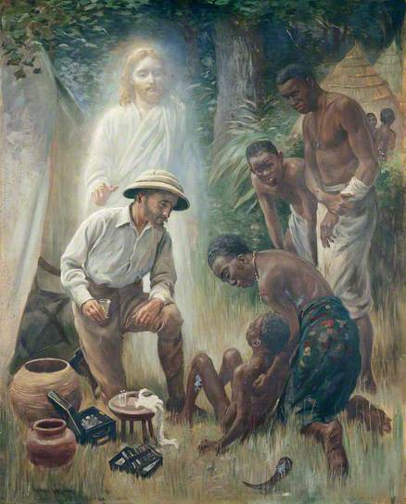
Figure 1 'A Medical Missionary Attending to a Sick African' By Harold Coping (1916)
Activity: Use the painting above to answer the following questions.
- What is happening in this painting?
- When was this painting painted?
- How does this painting reflect the teachings of Jesus Christ?
- Name one contemporary organization involved in similar work.

