Paul’s Journeys
Activity: As a result of this personal journey, Paul was inspired to spread the Gospel. To do this he had to travel, and travel he did! Read KWL pg. 64 and answer the questions below in the table.
First Journey  Who accompanied Paul on this journey?  When did this journey end?  What was Paul convinced of? | 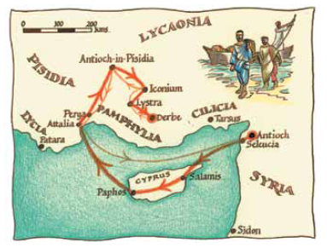
Second Journey  Who traveled with Paul on this journey?  Where did they spend a considerable amount of time? Why?  What was Paul’s message centered on? | 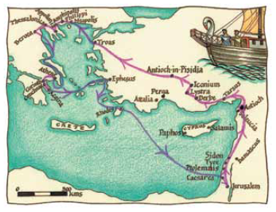
Third Journey  What was one of the groups Paul visited?  What did Paul preach against?  How did the local traders react to Paul’s message? | 